Color scale

Problem: When trying to correct for colorblindness it is important to make sure that the new colors are different enough to provide contrast. Problems can arise if there is a screen with, for example, green and red elements and they are changed to similar colors so that it is still difficult to differentiate them. In another case, how does the program determine if red text is over top of a green background? Some system needs to be in place to prevent elements from changing to colors that are too similar.

Solution: Color scale. Using a scale tailored to the type of color blindness it would be possible change all colors without worrying about position of elements or similarity between element colors. The scale would have two sides, in this example red and blue. Whatever end the current color is closest too determines what its new color will be instead of randomly selecting a color or simply removing the red or green hue from the element. By reserving certain hues for each side of the scale we can safely say that elements will be distinguishable from each other. Furthermore, we can make the new colors contrast with each other, so that we do not have to worry about the original problem of green text on a red background. Once those colors are changed to the new color, we know that they will contrast enough that the user will be able to clearly seem the text.

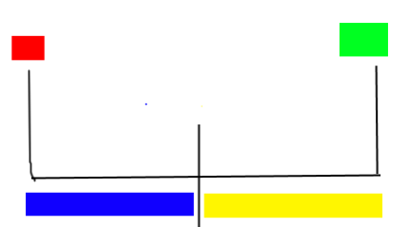

In the example given above, red hues would be replaced with a hue of blue, and green hues would be replaced with a hue of yellow.

We will need to determine what would be best for the new hues, as well as how specifically we will implement this system. We could try straight out replacing red values with blue values, so if an element has a red value of 45 we change it to blue 45, though this may mess up colors like purple. Some algorithm is needed to convert the values, and I feel it will be more complex than simply flipping numbers. It will likely require the analyzation of red green and blue values, and in some cases may not be needed. More research is needed. In case of time constraints a simplified system could be used that is similar to just flipping numbers.